PROJECT INTERCEPT
STRATEGIC PLAN
- Target Problem
  - Description of the Target Problem
As the second largest city in the country, Los Angeles has close to four million multicultural, multilingual residents (White: 49.8%; Hispanic or Latino: 48.5%; Asian: 11.3%; Black or African American: 9.6%; two or more races: 4.6%; and Native American: 0.7% - 2015 U.S. Census estimates). While public safety is a paramount concern for residents citywide, this worry is particularly acute in the South Los Angeles and Hollywood regions, which experience chronically high poverty, unemployment, and crime rates. Out of the 21 total Los Angeles Police Department (LAPD) divisions, the Southeast, Southwest and 77th Street divisions accounted for approximately 31% of all Part I violent crime (homicide, rape, aggravated assault, and robbery) from 2011 to 2013. In particular, the 77th division consistently ranks highest for the greatest amount of Part I violent crimes out of all divisions. In 2011, the Hollywood division rate of 38.8% per 1,000 residents was significantly higher than the 27.7% citywide rate for Part I crimes. These regions also both account for significantly higher arrest rates among the Latino and Hispanic populations as compared to other parts of the city.
The problems afflicting these communities have been entrenched for years. Solutions involving community reinvestment, broken window policing strategies and neighborhood councils have been implemented and met with limited success – yet crime persists. Innovative, new ideas are needed to address these communities’ intractable problems, including solutions that break the cycle of crime and incarceration to which so many have become accustomed. It is this context that provided the impetus for the Los Angeles City Attorney’s Office (LACA) to submit a 2014 grant proposal ushering in seminal Smart Prosecution strategies. Project INTERCEPT (“Introducing New Tools using Evidence and Risk-assessment to Confirm Eligibility for Prosecution Treatment") proposed implementing new criminal justice approaches to address public safety issues and strengthen the vulnerable South Los Angeles and Hollywood communities.
South Los Angeles
South Los Angeles suffers from poverty, violence, poor employment opportunities, disinvestment, and quality of life crimes. The population of South Los Angeles is 59% Latino, 37% African American and 1% white. The region is comprised of three Los Angeles Police Department (LAPD) divisions: Southeast, Southwest, and 77th Street. From 2011 through 2013, these three divisions accounted for approximately 31% of Part I crime (homicide, rape, aggravated assault and robbery) throughout the City of Los Angeles. In particular, the 77th Street division consistently ranks highest in violent crime among all 21 LAPD police divisions.
Hollywood
Similarly, Hollywood is plagued with high rates of poverty, poor job opportunities, and lack of quality, affordable housing. The region’s population is 48% Latino, 34% white, 12% Asian, and 4% African American. LAPD staffs one division: Hollywood. In 2011, the Hollywood division rate of 38.8% per 1,000 residents was significantly higher than the 27.7% citywide rate for Part I crimes.
Strained Court Impacts and Legislative Changes
Other factors impacting South Los Angeles and Hollywood at the time of the Project INTERCEPT application submission involved significant cuts to judicial resources, the consequences of which reduced opportunities to intercept individuals through the criminal justice system and redirect them away from escalating crime behavior. For example, recession-driven cutbacks culminated with the closure of eight Los Angeles County courthouses and 80 courtrooms, the termination of 1,000 court related positions, and the elimination of the Alternative Dispute Resolution Department. Currently, the court has begun to analyze its staff ing resources and is focusing its attention to rebuilding resources. For example, two new courtrooms have been in opened, one in downtown Long Beach and one San Fernando Valley. FT) With misdemeanor offenses consuming 40% of all judicial resources annually, misdemeanor court dockets became additionally strained, further attenuating the courts’ abilities to hear misdemeanor cases, tailor effective sentences, and monitor offenders.
In 2011, the California legislature passed AB 109 (Assembly Bill 109 (Stats. 2011, Ch. 5) enacted April 4, 2011; Pen. Code § 17.5), a prison realignment measure that shifted responsibility for 46,000 offenders from state prisons to county jails, further burdening overcrowded local jail resources. This in turn impacted jail sentences for misdemeanor offenders: as a result, misdemeanor defendants received significantly reduced jail terms and/or the court released them immediately following sentencing based upon credit for jail time already served. Jail sanctions no longer carried the same deterring effects on misdemeanor offenders, potentially emboldening them to commit more crimes.
- Smart Prosecution Approaches
  - Description of Evidence-Based and Innovative Strategies to Be Used
The goal of INTERCEPT is to implement evidence-based strategies to address target problems in the South Los Angeles and Hollywood communities by intercepting low-level, misdemeanor offenders before they escalate their criminal behavior and link them to individually tailored recommendations to prevent reoffending. Predicated on intensive crime analysis conducted in the first six months and accurate assessment of criminogenic factors and reoffending risks using an innovative misdemeanor risk assessment tool, INTERCEPT employs a pre-trial diversion model to prevent offenders from facing the harsh collateral consequences of a misdemeanor conviction.
First, LACA and its research partner, Justice and Security Strategy (JSS) engaged in data analysis of local crime issues, offenders and victims as described above. Second, INTERCEPT introduced a risk assessment tool applied by the INTERCEPT Administrative Coordinators to gauge eligible offenders for determination of levels of service engagement. The “MEBA” (Misdemeanor Evidence-Based Assessment) instrument is a combined risk-need screening tool designed by the Center for Court Innovation (CCI) in New York City. MEBA applies the well-supported theory of risk-need responsivity to misdemeanor populations. The tool allows the administrative coordinator to accurately classify an offender’s risk level and assess for known criminogenic needs, such as criminal thinking, anti-social associates, trauma, mental health, employment and education deficits and substance abuse. Based upon crime reports and the MEBA tool, administrative coordinators leverage resources by providing program participants with linkage to appropriate community-based services.
Third, INTERCEPT relies on Restorative Justice Principles for eligible participants from South Los Angeles and Hollywood. In lieu of criminal courts, restorative or neighborhood justice panels have been established to repair the harm caused by the offender in his/her community. Each neighborhood justice panel (NJP) consists of three volunteer community panelists, one offender/participant, a volunteer mediator facilitator, and victim (if willing to participate). Panels are being established in Hollywood (Youth Policy Institute) and South Los Angeles (Watts-Latin Community Action Committee) to lead transformational change for offenders, repair the harm and discuss with offenders ways to address the harm.
Research indicates the benefits of a restorative justice model. One study suggests that offenders participating in restorative practices are two-thirds less likely to reoffend.
  - Preliminary Restorative Justice Community Panel results elsewhere in the City
During the period of October 14, 2014 through October 2015, neighborhood justice panels previously established in the City of Los Angeles (in Pacoima, Van Nuys, Central LA and San Pedro) received 815 diversion referrals.
Out of the eight misdemeanor offenses currently-eligible for diversion participation, the overwhelming majority of referrals were for PC 484/490.5 Petty Theft/shoplifting (see chart below). The chart below breaks down diversion referrals by each of the City Attorney’s Criminal filing branches, further broken down by eligible charge:
Preliminary results for all diversion candidates city-wide (outside the INTERCEPT target area) who reached their six-month recidivism check date revealed a 2.6% recidivism rate. An immediate benefit of Project Intercept will be to incorporate the Needs/Risk Assessment tool into the existing process in order to analyze what other misdemeanor offenses can be appropriately treated through diversion. This will lead to more balance in the types of cases received, as well as to broader range of misdemeanor data to be collected and analyzed.
Project Intercept’s science-based approach will help the Los Angeles City Attorney’s Office make better decisions as the Office reviews different strategies designed to increase the number of diversion referrals citywide. One outcome is to test the efficacy of the restorative justice method by expanding the eligibility criteria, accepting offenders with one or more prior convictions, adding additional offenses to our list of diversion-eligible offenses, or a combination of all of the above.
  - Strategy Change
The only strategy change from the original grant application is the identification of a single risk assessment tool for implementation in Project INTERCEPT. Team members evaluated two different risk assessment tools to assess criminogenic needs and the propensity to commit future crimes. Instead of testing both risk assessment models in the first year of the project as stated in the grant application, one risk assessment tool, the “MEBA: instrument was selected for implementation. This comprehensive assessment was selected for its detail, including screening for trauma and substance abuse. A training program demonstrating use and application of the tool was delivered for staff in June 2015.
  - Policy Change
During the first six months of program implementation, petty theft crimes accounted for a high volume (nearly 90%) of INTERCEPT participants. LAPD experienced variations in its application process when identifying individuals for program participation and issuing citations in lieu of arrest. As a result, LACA has been working with the police department to revise and streamline the department’s policy for issuing citations for the offender to return to court. The goal is to conserve LAPD resources by avoiding arrest procedures for offenders eligible for INTERCEPT’s pre-trial diversion program.
  - Legislative Change – Proposition 47 Unintended Consequences
Shortly after the Smart Prosecution site announcement, in 2014 California voters passed a charge reduction referendum known as Proposition 47, intended to further reduce prison overcrowding by reducing non-serious, non-violent property and drug offenses from felonies to misdemeanors, with the cost savings being redirected toward treatment for drug offenders. Following Prop. 47’s implementation, California cities and counties experienced perceptible increases in property crimes. Within the City of Los Angeles, the LACA experienced a 47% increase in vehicle tampering prosecutions, 34% increase in petty theft prosecutions, and a 13% increase in battery prosecutions. Communities like South Los Angeles and Hollywood have been particularly hard hit as a result. The LACA and its partners are monitoring misdemeanor crime rates and are currently working with BJA TTA providers to assess the causal impacts of Prop. 47.
- Partnerships and Collaborations
The LACA has established partnerships and collaborations to enhance evidence-based practices for Project INTERCEPT. The LAPD is currently engaged in The Smart Policing Initiative and is sharing data with the INTERCEPT team. JSS, the research partner for both INTERCEPT and The Smart Policing Initiative is a nationally recognized leader in cutting edge criminal justice research and planning programs. The opportunity to combine Smart Policing, the Byrne Criminal Justice Initiative effort in Hollywood, and Smart Prosecution allows for comprehensive crime analysis and evaluation. Under Smart Policing, JSS has conducted crime analysis for gun-related and violent crimes, identifying problem locations using spatial analytics. Building upon Smart Policing and data-driven practices for INTERCEPT, JSS will examine characteristics of locations, suspects and victims for misdemeanor offenses.
The Center for Court Innovation (CCI), is nationally recognized for its research, development, technical assistance, and testing of new ideas for responses to criminal justice issues and reform. CCI provided technical assistance and evaluation of two risk assessment tools for potential use in INTERCEPT for the LACA. Upon the LACA selection of the CCI risk assessment, CCI provided training to INTERCEPT team members and other LACA staff for administering the risk assessment to misdemeanor offenders.
- Expected Results for INTERCEPT
The expected results of this approach include the following: (1) demonstrating cost effectiveness for INTERCEPT’s pre-trial diversion strategy for low-risk misdemeanor offenders; (2) increasing the current number of community justice panels in the target areas of Hollywood and South Los Angeles to four panels; (2) providing program and service referrals to address the participant’s risk and need level; (3) understanding the impact of criminal actions by the program participant and repairing the harm; (4) revising LAPD application process for identifying participants for Intercept and citation issuance in lieu of arrest; (5) building social ties for the program participant; (6) enabling participants to become law abiding citizens; (7) reducing recidivism rates for misdemeanor offenders; (8) relieving pressure on the court and correctional system; and (9) strengthening South Los Angeles and Hollywood communities.
- Long-Term Vision and Sustainment
The long-term vision and sustainment of the project is to continue the INTERCEPT Project beyond the life of the grant and expand the project to other districts within Los Angeles County. LACA expects to demonstrate project success, including cost efficiency and a decrease in recidivism rates to the Mayor and City Council to garner financial support for continuation of the program from the general fund.
- Impact Evaluation Plan
JSS will conduct a process and impact evaluation of INTERCEPT, focusing on the two Neighborhood Justice Panels (NJPs) in South Los Angeles and Hollywood.
For the process evaluation, JSS researchers will focus on how the initiative was planned and implemented by the LA City Attorney's Office (LACA). This portion of the evaluation will involve multiple methods, including interviews, reviews of pertinent documents, observations, and statistical analyses of LA CA offender and client-based data.
First, through interviews, conversations, and reviews of material, JSS will work with LACA staff to document how INTERCEPT works. That is, JSS will describe the theory and background and steps taken to implement the program. Second, JSS researchers will observe the actual operations of panels in South LA and Hollywood. Researchers will systematically describe the way in which panels work. A coding instrument will be developed to capture information about the physical layout of the “court,” the number of clients who participate (and their families and friends), the number of victims and other people in attendance, and the way in which the panelists deal with the case itself (charges, questions, disposition, etc.). Third, JSS will analyze data to provide a snapshot of the clients and how they compare to other clients in other parts of the city, and those who do not participate in the program – who they are (age, race, gender), their charges, and other characteristics.
An implementation report will be written for LA CA and BJA.
For the impact evaluation, JSS will analyze LACA data to determine the impact of INTERCEPT on recidivism of the clients who participate in the program. Clients will be tracked for a one-year period to determine re-arrests, re-charges, and re-convictions. In addition, data from a cohort of similar LACA misdemeanants with charges from 2011 will be analyzed to determine whether they differ in outcomes from INTERCEPT clients. This analysis will provide a comparison of those who went through the 'usual criminal process' of the LACA versus those who go through INTERCEPT.
An outcome evaluation report will be written for LACA and BJA.
- Logic Model
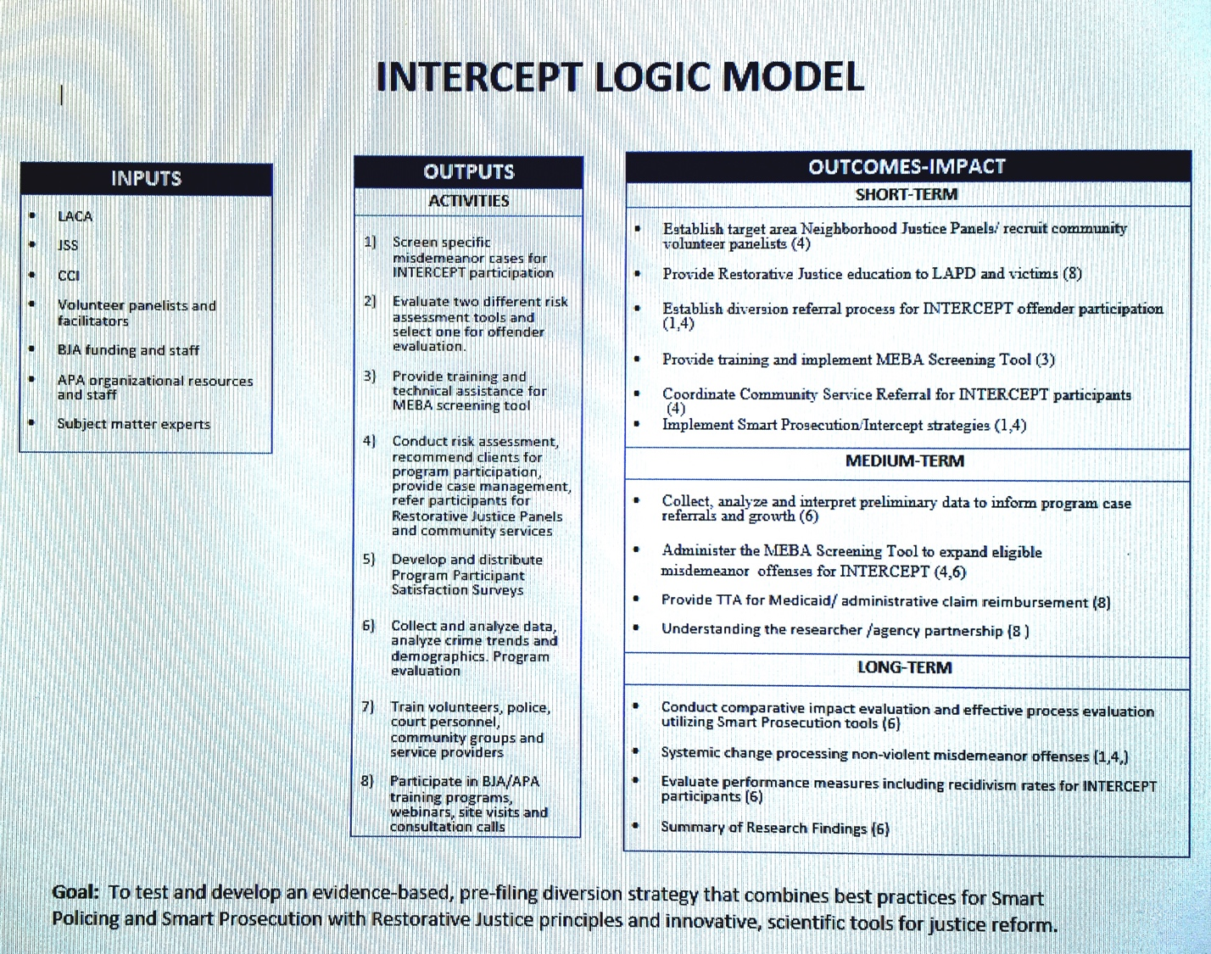

- Training and Technical Assistance
The LACA will engage with the Association of Prosecuting Attorneys (APA) for training and technical assistance on a variety of issues promoting INTERCEPT’s programmatic strategy and implementation. During the next six months technical assistance may include; (1) identifying a cognitive behavior curriculum or potential partner to develop a cognitive behavior curriculum for young adults admitted into the INTERCEPT program(2) assisting with legal analysis of the expungement and criminal record statutes, (3) identifying a SME and developing an agenda for motivational interview training skills program for INTERCEPT’s administrative coordinators, (4) developing an agenda and providing planning assistance for a June 2016 Colloquium highlighting INTERCEPT for LACA staff, NIP panelists and future volunteers, community members and service providers, (5) developing an agenda and planning a program featuring INTERCEPT for LAPD. It is anticipated the program will include a presentation of the evidence-based approach of INTERCEPT and relevant data, (6) identifying a SME and developing a risk assessment webinar training program, (7) assisting the site with sustainment plan development for INTERCEPT and, (8) assisting the site with strategy development for INTERCEPT program replications in other jurisdictions. This may include development of materials to inform the prosecutorial field.

.

Los Angeles unemployment rates: 11.3% (compared to 7.6% national rate - Bureau of Labor Statistics, 12/2012); Los Angeles poverty rates: 20.2% (compared to 14.4% national rate – American Community Survey, 2007-2011).
2013 LAPD Compstat Data
Industry and Labor Market Intelligence Report, August 2013, Los Angeles County Economic Development Corporation; 2013 LAPD Compstat Data; Changing Demographics of South LA, October 2011, Jared Sanchez and Jennifer Ito City of Los Angeles Workforce Investment Board; 2013 LAPD Compstat Data
Ibid.
2015 Los Angeles Superior Court Annual Report
Ibid; During FY 2014 prosecutors reviewed 118,000 criminal cases and filed 43,898 formal misdemeanor criminal complaints with the court and 34,850 citations.
California Assem. Bill 109, 2011
A conviction can impact an offenders’ ability to obtain employment, acquire a school loan, secure housing/public benefits and maintain healthy relationships.
⁹ Restorative Justice Consortium, The Positive Effect of Restorative Processes on Re-offending, London, March 2006 (citing evaluations and meta-analysis of programs in the U.S. and abroad achieving significant reductions in recidivism rates (56% in Belgium, 20% in Australia, 26% in the U.S.) when using restorative justice conferencing versus traditional court prosecutions. One Indianapolis study tracking 6-month and 12-month recidivism rates for conferenced versus court-processed offenders revealed reductions of 14% and 10%, respectively, at each recidivism check point).
7 participants out of a total of 268, reoffended within 6 months of initial arrest.
The Byrne Criminal Justice Innovation (BCJI) program was created as part of a larger, interagency effort across multiple federal agencies to assist distressed communities to both build capacity and revitalize neighborhoods.
Project Manager will meet with Mayor’s Office staff in March 2016 to explore a partnership with UCLA

